Location Map of Lecture Theatre 24
Faculty of Science
National University of Singapore

If you’re taking the MRT
- Alight at Buona Vista station
- Cross the bridge to the bus-stop in front of the Ministry of Education
- Transfer to SBS 95
- Alight at the bus-stop outside lecture theatre 27
- Walk to LT24

If you’re taking the bus
- Take SBS 97, 197 or 198
- Alight at the bus-stop opposite ITE Dover
- Take the sheltered walkway to campus ground and walk to LT24

If you are driving
- Take the Ayer Rajah Expressway
- Exit at South Buona Vista Road
- Take Lower Kent Ridge Road
- Park at Carpark 10 and walk to LT24

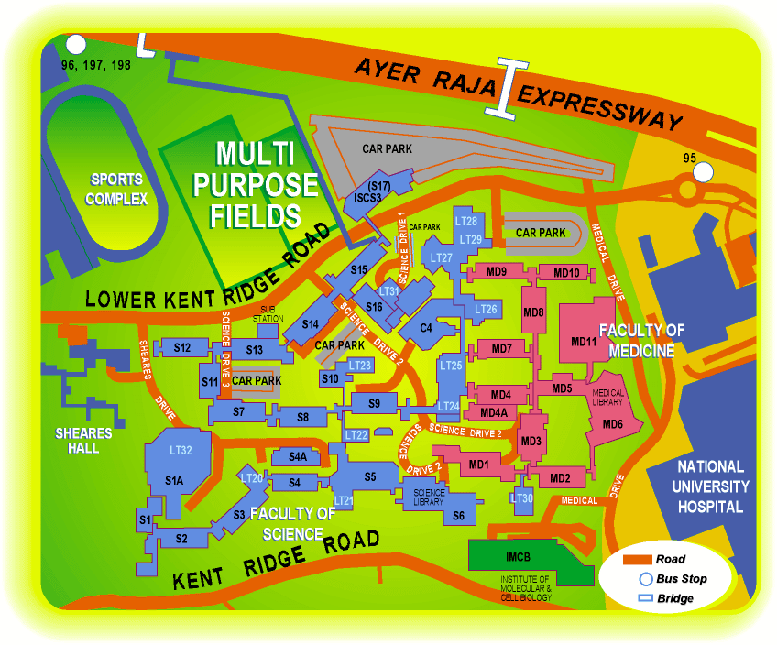
97, 197, 198
LT24
95
95
Carpark 10

